**CMF - MySQL Info-Gathering**

**of On-Premises / AZ cloud / Other Cloud**

**MySQL workload to Azure Database for MySQL - Flexible Server (PaaS)​** **- User Guide**

**For Script:**

**CMF-MySQL-CLI-Windows.ps1**

**CMF-MySQL-CLI-Linux.ps1**

**CMF-MySQL-Windows.ps1**

**CMF-MySQL-Linux.ps1**

**MySQL_Azure_****SingleServer_to_Flexible.ps1**



**Disclaimer:** These scripts are intended for use of Info Gather Assessment utility and do not interact with the user databases or gather any sensitive information (e.g. passwords, PI data etc.). These scripts are provided as-is to merely capture metadata information ONLY. While every effort has been made to ensure that accuracy and reliability of the scripts, it is recommended to review and test them in a non-production environment before deploying them in a production environment. It is important to note that these scripts should be modified with the consultation of Microsoft.

**Document Summary**

|  |  |
| --- | --- |
| **Document Item** | **Current Value** |
| Document Title | CMF - MySQL Info-Gathering of On-Premises / AZ cloud / Other Cloud MySQL workload to Azure Database for MySQL - Flexible Server (PaaS)​ - User Guide |
| Program | CSU Migration Factory |
| Date Last Modified | 19-Feb-2024 |
| Date Last Reviewed | 19-Feb-2024 |
| Current Document Known Issue | N/A |
| Status | Initial |
| Document Description | This document provides the procedure/steps to execute the Automation script which gathers the MySQL server details from Azure, Windows, Linux and Perform SS to FS Migration. |

**Revision History**

This section represents the change history of the document. Revisions of the document must be tracked by identifying a new version number, the date it was modified, the person making the change, and the reason for the change.

|  |  |  |  |  |
| --- | --- | --- | --- | --- |
| Date | Version | Change Description | Author | Reviewer |
| 18-Jan-2024 | 1.0 | Initial Version | Lekshmy, Arun, Mukesh, Chethan | Rackimuthu Kandaswamy |
| 18-Jan-2024 | 1.1 | Added SSL Mode | Chethan, Mukesh Lekshmy, Arun | Rackimuthu Kandaswamy, Sharad Khadtare |

|  |
| --- |
| **OS Support** This script is compatible with the following operating systems:  Windows 10 or later  Linux RHEL v7 or later, Ubuntu v14 or later **Pre-requisites** **Windows**  Powershell - <https://learn.microsoft.com/en-us/powershell/scripting/install/installing-powershell-on-windows?view=powershell-7.4>  MySQL Client - <https://dev.mysql.com/downloads/installer/>  Azure CLI (Only for Single Server) - <https://aka.ms/installazurecliwindows>  **Linux**  Powershell – <https://learn.microsoft.com/en-us/powershell/scripting/install/install-rhel?view=powershell-7.4>  MySQL Client - <https://dev.mysql.com/doc/mysql-shell/8.0/en/mysql-shell-install-linux-quick.html>  Azure CLI (Only for Single Server) - <https://learn.microsoft.com/en-us/cli/azure/install-azure-cli-linux> **Note: - Add PATH in Environment Variables** **Windows**  Azure CLI ( e.g. C:\Program Files\Microsoft SDKs\Azure\CLI2\wbin )  MySQL Client ( e.g. C:\Program Files\MySQL\bin )  **Linux**  Azure CLI ( e.g. /usr/bin/az )  MySQL Client ( e.g. /usr/bin/mysql ) **Steps To-Do:****Step1. Azure CLI Info Gathering (Only for Azure Database for MySQL Single Servers)**  1. Download the package zip file named MySQL-Info-Gather.zip 2. Extract the unzip MySQL-Info-Gather.zip file. 3. Run **rename rename.txt rename.bat** and execute the rename.bat (Windows) 4. Run **sh ./rename-linux.txt** (Linux) 5. Open the Input file Azure_Subscription.csv and provide the Tenant ID & Subscription ID 6. Execute **powershell.exe .\CMF-MySQL-CLI-Windows.ps1** (Windows) 7. Execute **pwsh ./CMF-MySQL-CLI-Linux.ps1** (Linux) 8. Once the execution is completed, you can check the output & Logs folder.  **Step2. Update CMF_MySQL_Server_Input_file.csv (Mandatory)** "**Host_Name**","Resource_Group","**Port**","VCore","Auth_Type","**User_ID**","**Password**","**DB_Name**","Tenant","Subscription_ID","**Approval_Status**","SSL_Mode"  **Note: -** . Highlighted are **Mandatory Fields** . Password field is optional but should be provided during script execution if omitted. . Update Mandatory fields manually in the case of On-premises / Azure VM / Other Cloud Servers. **Step3. MySQL Server Info Gathering (Mandatory)**  1. Execute **powershell.exe .\CMF-MySQL-Windows.ps1** (Windows) 2. Execute **pwsh ./CMF-MySQL-Linux.ps1** (Linux) 3. Once the execution is completed, you can check the output & Logs folder.  **Step4. Only for On-Premises / Azure VM / Other Cloud Servers** . Refer document CMF-ON-Prem_Server_Info_gather.docx from the zip folder and update details and share document.  Host-Name | Cores | Memory | Storage Size | Storage Type | OS type | OS version | IOPS. **Step5. Zip and share output, log folders (Mandatory for all servers)** Kindly follow the execution instructions mentioned in the attached documents. If there is/are any queries, please let us know, we will connect and check.  . |

Table of Contents

1 Executive Summary 7

1.1 Objective 7

2 Prerequisites for MySQL Server Info gathering script execution 7

2.1 Operating System Requirements 7

2.2 Software requirements 7

3 Azure MySQL single server Info-Gathering 7

3.1 Scripts Folder 7

3.2 Renaming Scripts 8

3.3 Preparing the INPUT CSV File- **Azure_Subscription.csv** 9

3.4 Script Execution. 9

• Open windows Command prompt as **Administrator** 9

3.4.1 Create support folders(Logs, Output, Downloads etc) 10

3.4.2 Validate Azure CLI 10

3.4.3 Azure Portal authentication 11

3.4.4 Export Info-Gathering details and generating JSON files. 12

3.4.5 Azure MySQL Single Server JSON output 12

3.4.6 Azure MySQL Single Server Output 12

3.5 Automation Script Transcript Log 13

4 MySQL Server Info-Gathering for Windows 13

4.1 Scripts Folder 13

4.2 Renaming Scripts 14

**4.3** Preparing the INPUT CSV file- **CMF-MySQL_Server_Input_file.csv** 14

4.4 CMF-MySQL-Windows – Script execution 15

4.5 Export Info-Gathering details and generating Output Log files. 17

4.6 Automation Script Transcript Log 17

5 MySQL Server Info-Gathering for Linux 17

5.1 Script Folder 17

5.2 Renaming Scripts 18

5.3 Preparing the INPUT CSV file- **CMF-MySQL_Server_Input_file.csv** 18

5.4 CMF-MySQL-Linux – Script execution 19

5.5 Export Info-Gathering details and generating Output log files 20

5.6 Automation Script Transcript Log 21

6 Migration Single server to Flexible server 21

6.1 Azure MySQL to Flexible server Migration execution 21

6.2 Preparing the INPUT CSV File 22

6.3 Creating support folders (Logs, Output, Downloads etc) 22

6.3.1 Validate Azure CLI 23

6.3.2 Azure MySQL Single Server and Flexible JSON output 25

6.4 Automation Script Transcript Log 25

7 Appendix. 26

7.1 Checking error logs 26

7.2 Input CSV file- **Azure_Subscription.csv** 26

7.3 Input CSV file - **CMF-MySQL_Server_Input_file.csv** 27

7.4 Internet access to the URLs below: 28

7.5 Without Internet access to the URLs 29

7.6 Installing Azure CLI for Windows and Linux 29

7.7 PowerShell Version, Modules & Execution policy 29

7.8 PowerShell Installation on Linux 30

7.9 Adding mysql as an environment variable in Windows 30

7.10 Adding Azure CLI as an environment variable in Windows 33

# 1 Executive Summary

## Objective

This document provides the procedure/steps to execute the Automation script

(CMF-MySQL-CLI-Windows.ps1, CMF-MySQL-CLI-Linux.ps1, CMF-MySQL-Windows.ps1,

CMF-MySQL-Linux.ps1, MySQL_Azure_SingleServer_to_Flexible.ps1) which gathers the MySQL Server details from Azure, Windows, Linux, and SS to FS Migration.

Note: This Automation Script does not fetch/access any of the user database data. The values present in the Screenshots are demo values. Please change the values as Appropriate.

# Prerequisites for MySQL Server Info gathering script execution

## Operating System Requirements

* Supported Operating System
  + Windows 10, Windows Server 2012, Windows Server 2012 R2 and above
  + Linux - RHEL v7 & above, Ubuntu v14 & above

## Software requirements

* MySQL Client 5.6 and above
* Azure CLI (To gather Azure Database for MySQL single server)
* PowerShell 5.1 and above.

# Azure MySQL single server Info-Gathering

## 3.1 Scripts Folder

* Unzip the **MySQL-Info-Gather** zip file received by CMF team.

## Renaming Scripts

* Execute the following command in MySQL-Info-Gather folder to rename the scripts from .txt to .ps1 on **Windows** Command Prompt.

rename rename.txt rename.bat

* Execute rename.bat file.

rename.bat

* Execute the following command in MySQL-Info-Gather folder to rename the scripts from .txt to .ps1 on Linux Terminal.

sh rename-linux.txt

## Preparing the INPUT CSV File- **Azure_Subscription.csv**

In Order to support the Info Gathering process, INPUT CSV FILE (**Azure_Subscription.csv**) should be provided with Azure Subscription data.

**Each column will represent an Azure Subscription detail for Azure MySQL Single Server Info Gathering**

## Script Execution

* Open windows Command prompt as **Administrator**
* Change the working directory/folder to the folder MySQL-Info-Gather where the scripts are present.
* Enter the following command at the windows command prompt to **trigger** the

**CMF-MySQL-Trigger script.**

**For Windows: Powershell.exe -ExecutionPolicy RemoteSigned -File .\CMF-MySQL-CLI-Windows.ps1**

**For Linux: pwsh ./** **CMF-MySQL-CLI-Linix.ps1**

### Create support folders(Logs, Output, Downloads etc)

After triggering the automation all the support folders (Logs, Output, Download etc.) will be created automatically by the automation script in the MySQL-Info-Gather folder

### Validate Azure CLI

* Automation script validates the Azure CLI. If not found, automation will initiate installation.

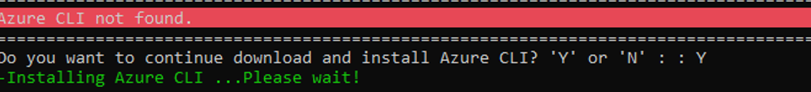

* Once Azure CLI Installation completes successfully and if you encounter the above error message kindly close the Command Prompt and validate Azure CLI by re-running the automation script again.

* PowerShell version and Azure CLI are validated successfully.

### Azure Portal authentication

* **Automation requires Azure portal authentication.**
* **For Linux:** Copy the device login URL and code to authenticate



### Export Info-Gathering details and generating JSON files.

Once Azure portal authentication is successful, Automation gathers MySQL Single server details to update them in csv files. Also, Azure MySQL CLI’s commands output will be exported to JSON files.

* The JSON files can be found in the Folder Output 🡪 Single.

### Azure MySQL Single Server JSON output

The Following JSON output files will be generated for each Azure MySQL Single Server from the given Azure subscription.

### Azure MySQL Single Server Output

* CSV files will be generated for all the MySQL Single Server/Instance(s) from the given Azure subscription. Azure CLI’s output are as follows.

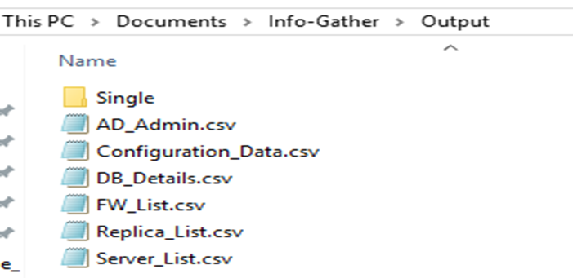

**Note:** Output files will be generated in CSV format as above

**Note:** Please share compressed Output and Logs Folder to CMF team

## Automation Script Transcript Log

**Note:** For the Automation, transcript will be generated in text format as above

# MySQL Server Info-Gathering for Windows

## Scripts Folder

* Unzip the **MySQL-Info-Gather** zip file received by CMF team.

## Renaming Scripts

* Execute the following command in MySQL-Info-Gather folder to rename the scripts from .txt to .ps1 on **Windows** Command Prompt.

rename rename.txt rename.bat

* Execute rename.bat file.

rename.bat

## Preparing the INPUT CSV file- **CMF-MySQL_Server_Input_file.csv**

In Order to support the Info Gathering process, INPUT CSV FILE   
(**CMF-MySQL_Server_Input_file.csv**) should be provided with MySQL Server details.

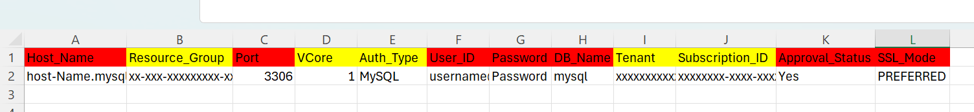

* Provide the Mandatory fields highlighted in red color.

## CMF-MySQL-Windows – Script execution

* Open windows Command prompt as **Administrator**
* Change the working directory/folder to the folder MySQL-Info-Gather where the scripts are present.
* Enter the following command at the windows command prompt.

**Powershell.exe -ExecutionPolicy RemoteSigned -File .\CMF-MySQL-Windows.ps1**

**Note:** After triggering the automation all the support folders (Logs, Output, Downloads etc.) will be created automatically by the automation script, mysql path is validated, and it will ask user to proceed with the execution of the script.

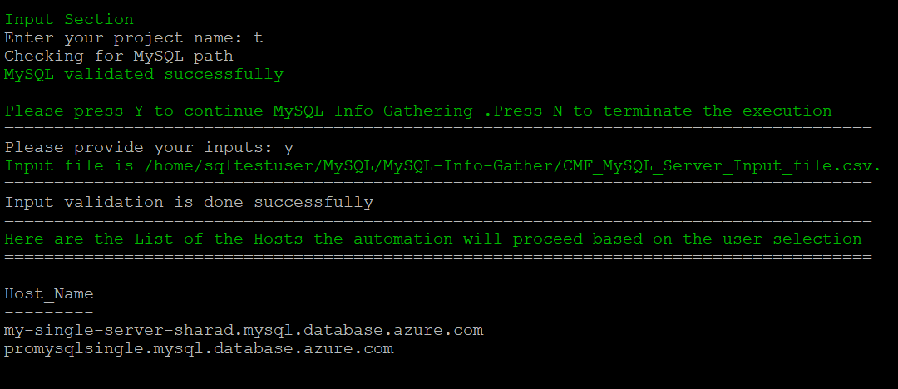

* The script then Validates the list of approved Hosts to proceed with execution. Continue by Entering “Y” and provide your Project Name. You’ll get below final Status of the Script Execution.
* Please Enter “Y” to perform Info Gathering of Hosts above, otherwise Enter ‘N’ to terminate the execution.

**Note:** Ensure you add the location of psql.exe to your Path environment variables

## Export Info-Gathering details and generating Output Log files.

* Output log files are generated for each MySQL Server as shown in the Output Folder below.

## Automation Script Transcript Log

**Note:** For the Automation, transcript will be generated in text format as above

**Note:** Please Share the Compressed Output and Logs Folder with the CMF Team.

# MySQL Server Info-Gathering for Linux

## Script Folder

* Unzip the **MySQL-Info-Gather** zip file received by CMF Team

**Commands:**   unzip filename.zip

    cd /MySQL-Info-Gather

                       ls -lrt

## Renaming Scripts

* Execute the following command in MySQL folder to rename the scripts from .txt to .ps1

**sh rename-linux.txt**

## Preparing the INPUT CSV file- **CMF-MySQL_Server_Input_file.csv**

* In Order to support the Info Gathering process, INPUT CSV FILE   
  (**CMF-MySQL_Server_Input_file.csv**) should be provided with MySQL Server details.



* Provide the Mandatory fields highlighted in red color.

## CMF-MySQL-Linux – Script execution

* Open Putty/Linux Terminal, connect to the server and execute the script.
* Change the working directory/folder to the folder MySQL-Info-Gather where the scripts are present.
* Enter the following command to execute the script.

**pwsh ./CMF-MySQL-Linux.ps1**

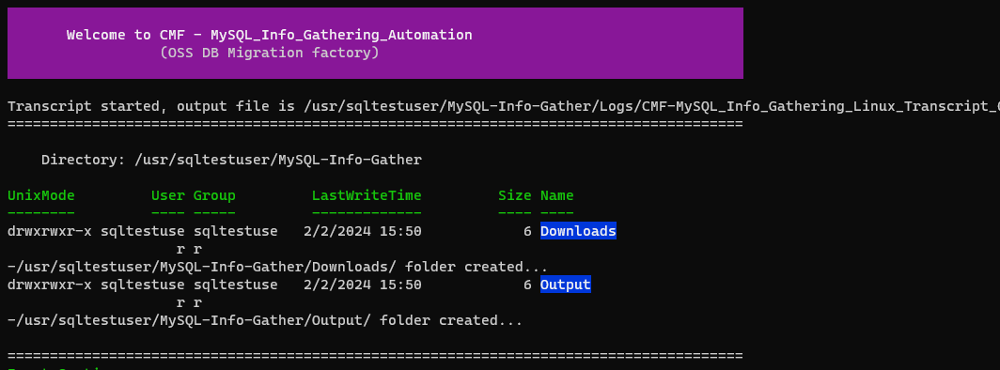

**Note:** After triggering the automation all the support folders (Logs, Output, Downloads etc.) will be created automatically by the automation script, Mysql path is validated, and it will ask user to proceed with the execution of the script.

The script then Validates the list of Hosts to proceed with execution. Continue by Entering “Y” and provide your **Project Name**. You’ll get below Final Status of the Script Execution.

Note: Ensure you add the location of Mysql.exe to your Path environment variables

* List of the Hosts the automation will proceed based on the user selection.

* Next, enter “Y” to proceed MySQL server Info-Gathering.

* Final Execution

## Export Info-Gathering details and generating Output log files

* Output log files are generated for each MySQL Server as shown in the Output Folder below.

## Automation Script Transcript Log



**Note:** For the Automation, transcript will be generated in text format as above

**Note:** Please Share the Compressed Output and Logs Folder with the CMF Team.

# Migration Single server to Flexible server

## Azure MySQL to Flexible server Migration execution

* Create a folder MySQL-Single-to-Flexi (you may choose any available drive)
* Copy the provided script files and folder Validation_Scripts under the folder created in the previous step. For example: If “MySQL-Single-to-Flexi” was the folder created in the previous step, then copy the Validation_Scripts & files under the MySQL-Single-to-Flexi Folder.
* Open windows Command prompt as **Administrator and** Change the working directory/folder to the folder (MySQL-Single-to-Flexi) where you created/copied the script files and folder in the previous step.
* Execute below command to Rename “rename.txt” file to “rename.bat”.

rename rename.txt rename.bat

* Once renamed, Execute rename.bat on command prompt. This will change the extension of desired PowerShell script files from .txt to .ps1.

rename.bat

## Preparing the INPUT CSV File

* In Order to support the Info Gathering process, INPUT CSV FILE (**Azure_Subscription.csv**) should be provided with Azure Subscription data.
* **Each column will represent an Azure Subscription detail for Azure MySQL Single Server Info Gathering**

* Enter the following command at the windows command prompt to trigger the CMF-MySQL_Azure_SingleServer_to_Flexible.ps1 script

**Powershell.exe -ExecutionPolicy RemoteSigned -File .\CMF_MySQL_Azure_Trigger.ps1**

## Creating support folders (Logs, Output, Downloads etc)

* After triggering the automation all the support folders (Logs, Output, Downloads etc.) will be created automatically by the automation script in the “MySQL-Single-to-Flexi” folder.

### Validate Azure CLI

* Automation script validates the Azure CLI. If not found, automation will initiate installation.

* Once Azure CLI Installation completes successfully and if you encounter the above error message, kindly close the Command Prompt and validate Azure CLI by re-running the automation script again.

MySQL client, PowerShell version and Azure CLI are validated successfully.

* Once prerequisite module installation verified, script will list all the approved server and prompt for user input to continue for flexible server provisioning and migration as shown below…

* Once confirmed by providing input ‘Y’ script will proceed to flexible server provisioning and migration. After processing all approved servers, script will display the final status table as below…

**Note**: Provisioning each flexible server can take from 5 mins to 30 mins for storage size less than 1 TB but can take more than 30 mins if size more than 1TB depending on the MySQL databases size on each server.

### Azure MySQL Single Server and Flexible JSON output

* The Following resource JSON files will be generated in output folder for each Azure MySQL Single Server and Flexible MySQL server as below.



## Automation Script Transcript Log

* Transcript will be generated in text format in Logs folder in below mentioned name

(.\Logs\CMF_MySQL_Azure_SingleServer_to_Flexible_Automation_Transcript_YYYYMMDDHHMMSS.txt)

# Appendix.

## Checking error logs

* If script execution fails due to some errors, check the detailed error log in

**Output->folder -> folder mysqlxxx.mysql.database.azure.com.log file.**

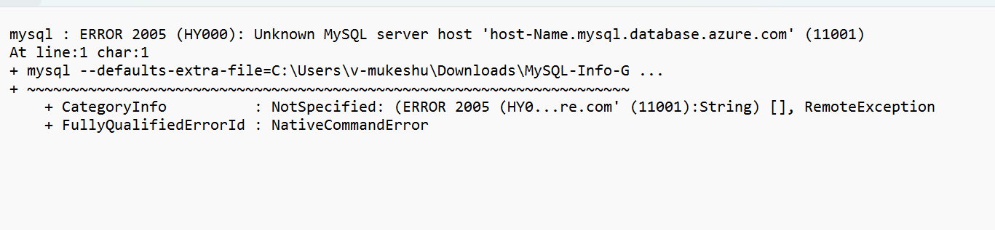

## 7.2 Input CSV file- **Azure_Subscription.csv**

**Important Notes:**

* This script is based on the csv file named ‘Azure_Subscription’ and the following columns in the Input csv file
* INPUT CSV FILE name must be **Azure_Subscription.csv**
* **Column Name must be kept as shown below, change in names will result in errors.**
* **Values in the column must be correct, incorrect values will also result in error**

|  |  |  |
| --- | --- | --- |
| **Seq.No** | **File** | **Note** |
| 1 |  | Sample: **Azure_Subscription.csv** |

## 7.3 Input CSV file - **CMF-MySQL_Server_Input_file.csv**

**Important Notes:**

* MySQL Client is required to establish Connectivity to MySQL Servers.
* This script is based on the CSV file named ‘CMF-MySQL_Server_Input_file.csv’.
* Column Name must be kept as shown below, change in names will result in errors.
* Values in the column must be correct, incorrect values will also result in errors.
* Tenant and Subscription_ID columns are Optional.
* Password field is optional but should be provided during script execution if omitted.

1. **Columns for Input File: CMF-MySQL_Server_Input_file.csv**

|  |  |
| --- | --- |
| **Column Name** | **Note** |
| **Host_Name** | Provide Host Name (Example: localhost) |
| **Port** | Provide Port Number (Example: 3306) |
| **User_ID** | Provide the User_ID |
| **Password** | Provide the Password |
| **DB_Name** | Provide Database Name (Example:mysql) |
| **Tenant** | Azure Subscription tenant ID (Optional) |
| **Subscription_ID** | Azure Subscription ID (Optional) |
| **Approval Status** | Provide YES to fetch the information and NO to exclude the host. |
| **SSL_Mode** | Provide SSL_Mode (Example : preferred) |

|  |  |  |
| --- | --- | --- |
| **Seq.No** | **File** | **Note** |
| 1 |  | Sample**: CMF-MySQL_Server_Input_file.csv** |

## Internet access to the URLs below:

|  |  |
| --- | --- |
| **URL** | **Note** |
| <https://aka.ms/installazurecliwindows> | Azure CLI |
| <https://learn.microsoft.com/en-us/cli/azure/install-azure-cli-linux?pivots=dnf> | Azure CLI (Linux) |
| <https://aka.ms/PSWindows> | PowerShell (Windows) |

## Without Internet access to the URLs

* **Note:** Follow the instructions below to download all the software manually to a server where internet connectivity is enabled. Once all the software is downloaded, move all of it to the server where MySQL Automation script will be executed and install all of them one by one.

## Installing Azure CLI for Windows and Linux

Windows - <https://aka.ms/installazurecliwindows>

Linux - https://learn.microsoft.com/en-us/cli/azure/install-azure-cli-linux

## PowerShell Version, Modules & Execution policy

Execute the below commands from windows PowerShell as Administrator.

1. To find the PowerShell Version

* **Get-Host**

1. Set the PowerShell execution policy

* **Set-ExecutionPolicy Unrestricted -Scope CurrentUser**



## PowerShell Installation on Linux

* Register the Microsoft RedHat Repository

curl https://packages.microsoft.com/config/rhel/7/prod.repo | sudo tee /etc/yum.repos.d/microsoft.repo

* Install PowerShell

sudo yum install –assume yes powershell

* Start PowerShell

Pwsh

## Adding mysql as an environment variable in Windows

* To add the MySQL Client to your environment path, you'll need to modify the system's PATH environment variable to include the directory where the MySQL Client is located. Below are the steps to add the mysql client to the system env path,

1. After the installation, open Start menu, search for Environment variables and select “Edit the system Environment variables”

1. In the System Properties window, click the “Environment variables”

1. Next, in the Environment variables window, under “Systemvariables” section, select Path and click “Edit”

1. Click the “New” button and add the installation path or Browse to navigate and add the MySQL Client installation directory path (e.g. **C:\Program Files\MySQL\16\bin or the path where MySQL Client is installed)** as shown below

1. Click “OK” to close each window.

## Adding Azure CLI as an environment variable in Windows

* To add the Azure CLI to your environment path, follow the steps below,

1. After installation, open the Start menu, search for "Environment Variables," and select "Edit the system environment variables."
2. In the System Properties window, click the "Environment Variables" button.
3. In the Environment Variables window, under the "System variables" section, find and select the "Path" variable, then click the "Edit" button.
4. Click the "New" button and add the path to the Azure CLI installation directory (e.g., C:\Program Files\Microsoft SDKs\Azure\CLI2\wbin).
5. Click "OK" to close each window.

* Verify by opening a new Command Prompt or PowerShell window and type “az” to verify that the Azure CLI is now accessible.